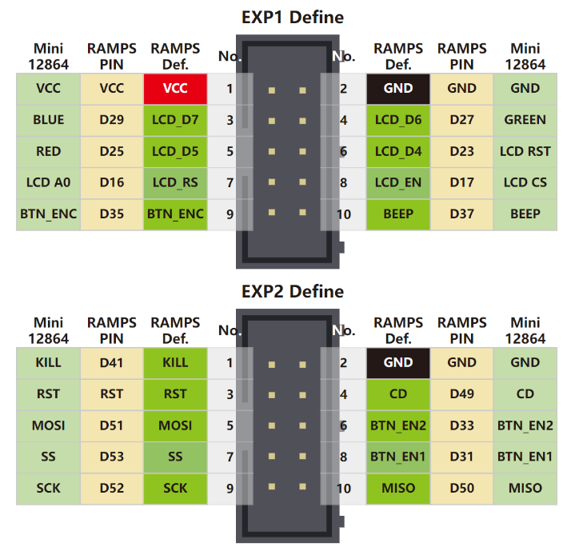

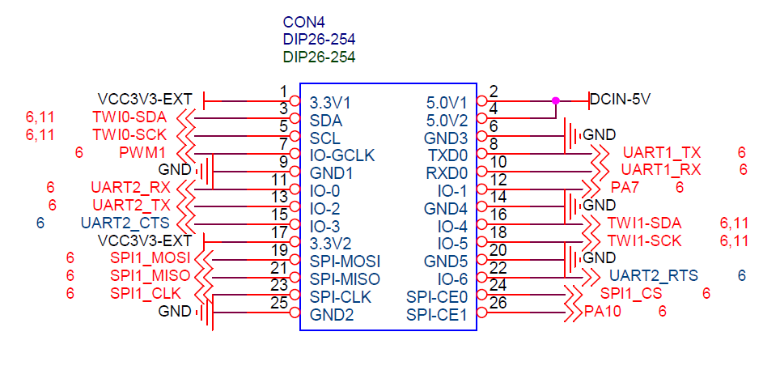

PN5180 CON4 Description

Pin1 Pin 4 5V

Pin2 Pin 1 3V

Pin3 Pin 16 PA19 RESET

Pin4 Pin 26 PA13 NSS (CS)

Pin5 Pin 19 MOSI

Pin6 Pin 21 MISO

Pin7 Pin 23 CLK

Pin8 Pin 18 Busy

Pin9 Pin 20 GND

Pin10 GPIO

Pin11 PA18 IRQ

Pin12 Aux

Pin13 Req

FYSETC CON4

EXP1 pin 1 pin 1 VCC

EXP1 pin 2 pin 6 GND

EXP1 pin 3 pin 13 PA00 RGB BLUE

EXP1 pin 4 pin 11 PA01 RGB Green

EXP1 pin 5 pin 15 PA03 RGB RED

EXP1 pin 6 pin 22 PA02 (LCD_RST)

EXP1 pin 7 pin 12 PA07 (A0 in driver ST7567)

EXP1 pin 8 pin 24 PA10 SPI1_CS

EXP1 pin 9 pin 3 PA12 BTN_ENC

EXP1 pin 10 pin 7 PA06 Beep

EXP2 pin 5 pin 19 PA15 SPI1_MOSI

EXP2 pin 6 pin 8 PG06 BTN_ENC1 (192 + 6)

EXP2 pin 8 pin 10 PG07 BTN_ENC2 (192 + 7)

EXP2 pin 9 pin 23 PA14 SPI1_CLK

Xxxx = connected with clockMod circuit

Xxxx = shared connection (splitcable)

Xxxx = shared connection (splitcable)